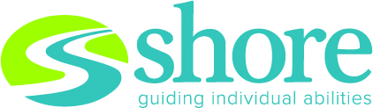

**2025 Spring Benefit   
Thursday, April 24, 2025   
Pinstripes Northbrook**  
**SPONSORSHIP OPPORTUNITIES**

**Triple Crown Sponsor $25,000+**• Marquee company logo and name on invitation   
• Full page presenting sponsor recognition in program   
• Recognition on agency website, newsletter/correspondence, and social media   
• Signage at event with prominent company logo placement   
• Table of 10 at the Benefit & 2 foursomes at   
Golf Outing in September

**Derby Day Champion Sponsor $15,000+**• Company logo and name on invitation   
• Full page sponsor recognition in program   
• Recognition on agency website, newsletter/correspondence, and social media   
• Signage at event with company logo   
• Table of 10 at the Benefit & 2 foursomes at   
Golf Outing in September

**Winner’s Circle Sponsor $10,000+**   
• Company logo and name recognition on invitation   
• Half page sponsor recognition in program   
• Recognition on agency website, newsletter/correspondence, and social media  
• Signage at event with company logo   
• Table of 10 at the Benefit & 1 foursome at   
Golf Outing in September

**Run for the Roses Sponsor $5,000+**• Company logo and name recognition on invitation   
• Half page sponsor recognition in program   
• Recognition on agency website, newsletter/correspondence, and social media   
• Signage at event with company logo   
• 1 table of 10 at the Benefit & 1 foursome at Golf Outing in September

**Hoofbeats Hero Sponsor $2,500+**• Quarter page sponsor recognition in program   
• Recognition on agency website, newsletter/ correspondence, and social media   
• Signage at event with company logo

**Finish Line Sponsor $500+**• Listing as a contributor in program   
• Recognition on social media

**Gallop Supporter $100+**• Listing as a contributor in program